Task 3: Configure Network Security Groups (NSGs)
What to do:
Create three NSGs and associate them with their respective subnets:
NSG | Rules | Associate With
nsg-novatech-{id}-web | Allow inbound HTTP (80) and HTTPS (443) from Any | WebSubnet
nsg-novatech-{id}-app | Allow inbound port 8080 from WebSubnet only (10.0.1.0/24) | AppSubnet
nsg-novatech-{id}-data | Deny all inbound from Internet. Allow inbound from AppSubnet only (10.0.2.0/24) | DataSubnet
Acceptance Criteria:
- Each NSG exists and is associated with the correct subnet
- WebNSG allows 80 and 443 from Any source
- AppNSG allows 8080 only from 10.0.1.0/24
- DataNSG has an explicit deny for Internet and allow from 10.0.2.0/24

Create Network Security Group
- In the search box at the top of the portal, type Network Security Group. Select Network Security group in the search results.
- Select + Create.

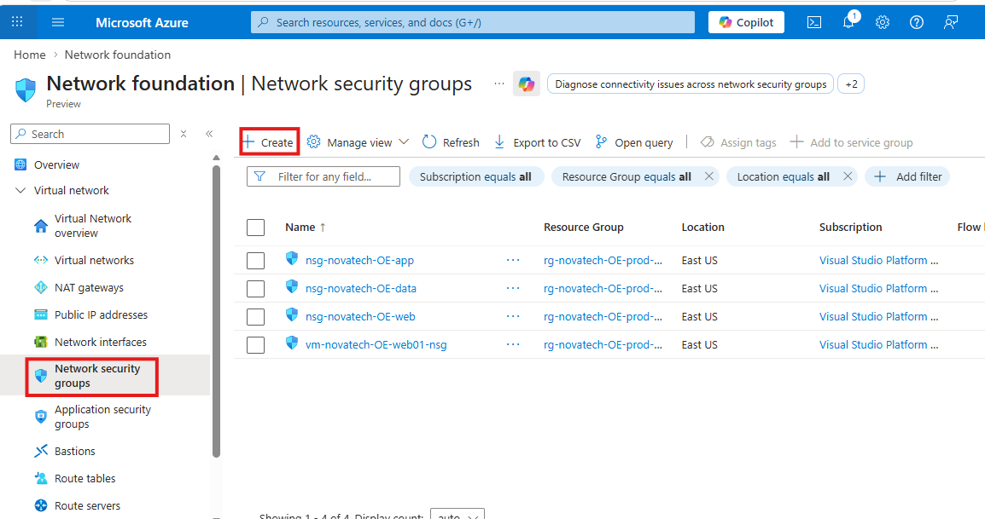

- On the Basics tab of Create virtual network, enter, or select the following information:
Enter the following values:
- Subscription: Select your Azure subscription.
- Resource Group: Select the previously created RG
- Name: Give the Network Security group a name.
- Region: Select an Azure location East US

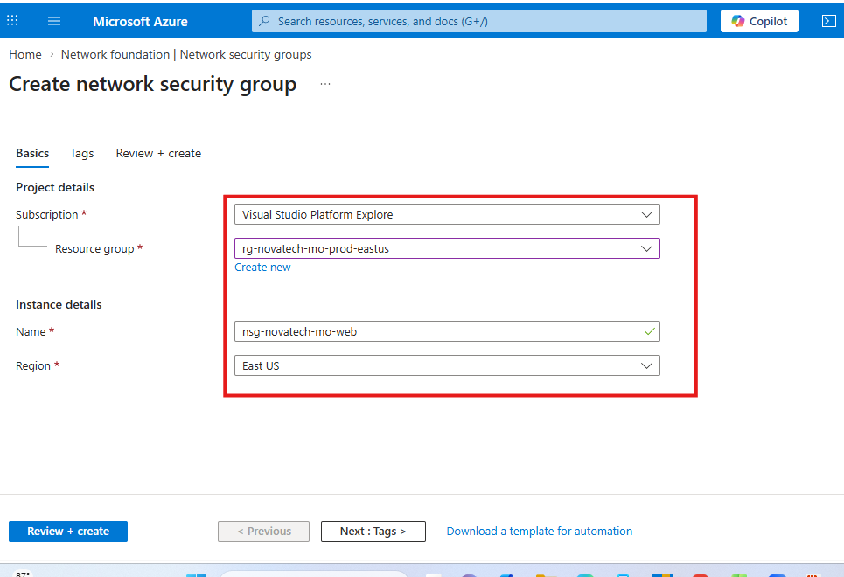

Click on Review and Create
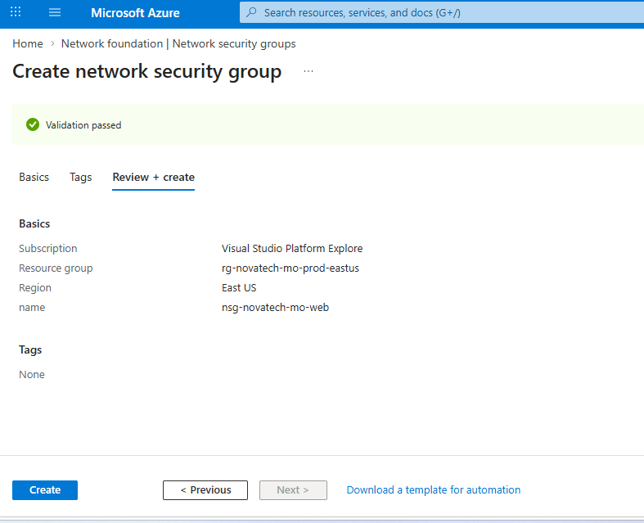

Network Security Group has been created.
Click on Go to resource
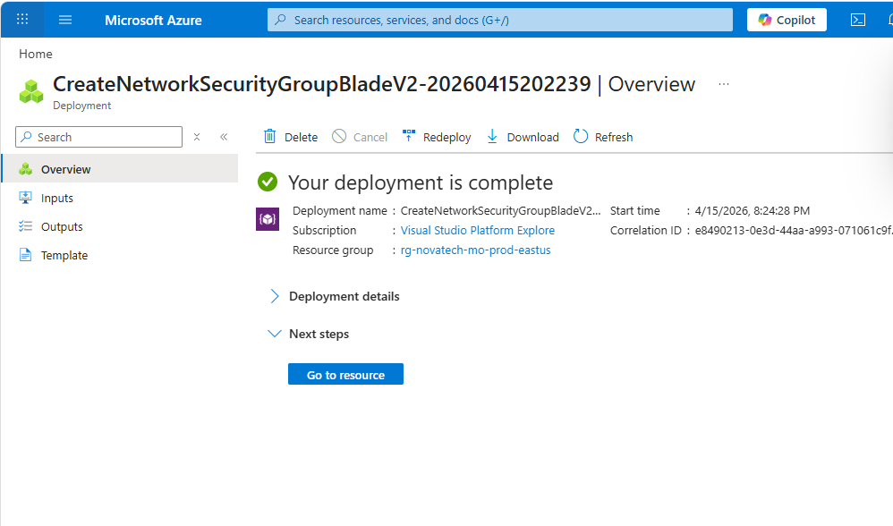
Three network security groups were created.
WebNSG
AppNSG
DataNSG
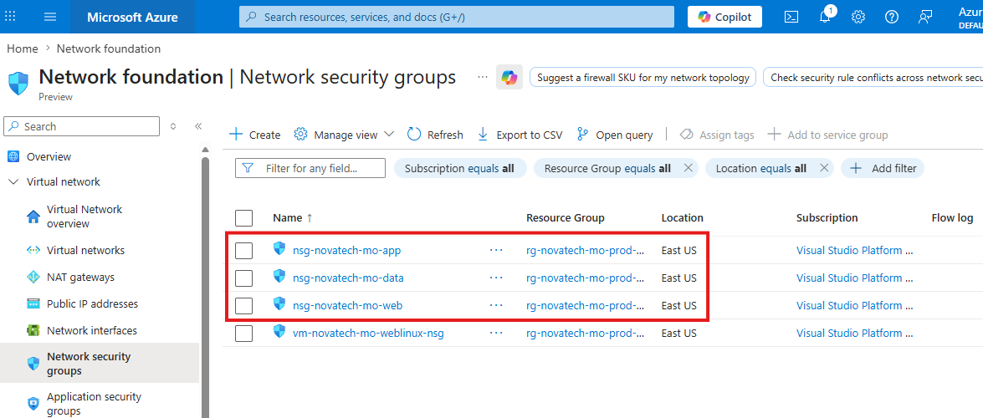

To associate the NSGs with their respective Subnets
Select the Network Security Group you want to associate with
Select Settings >> Click on Subnets
Click on + Associate
Select Subnet to Associate with the NSG. Click OK
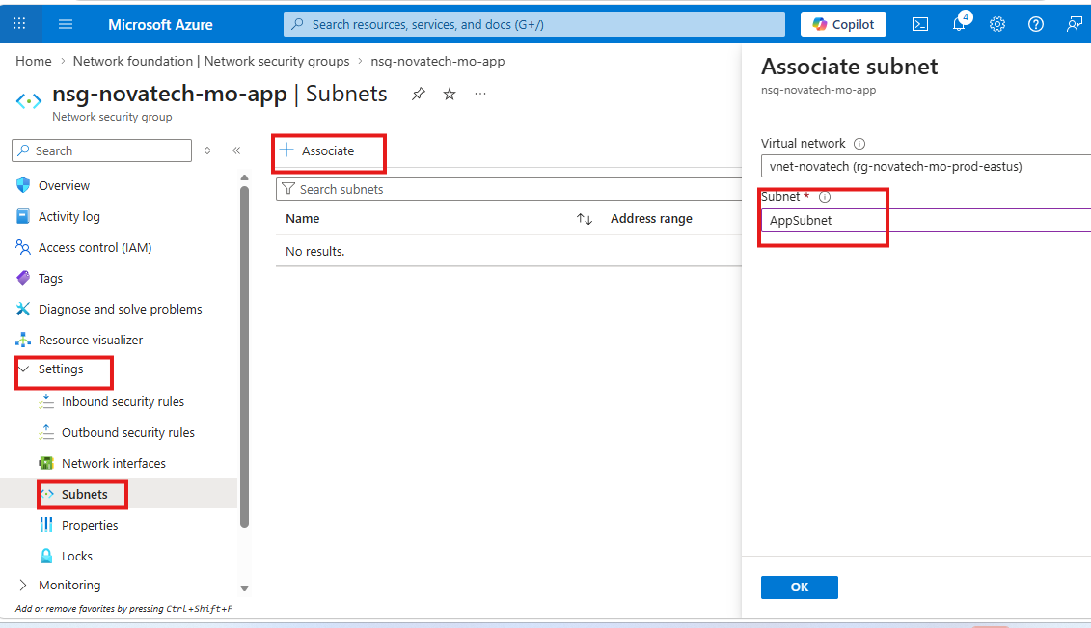
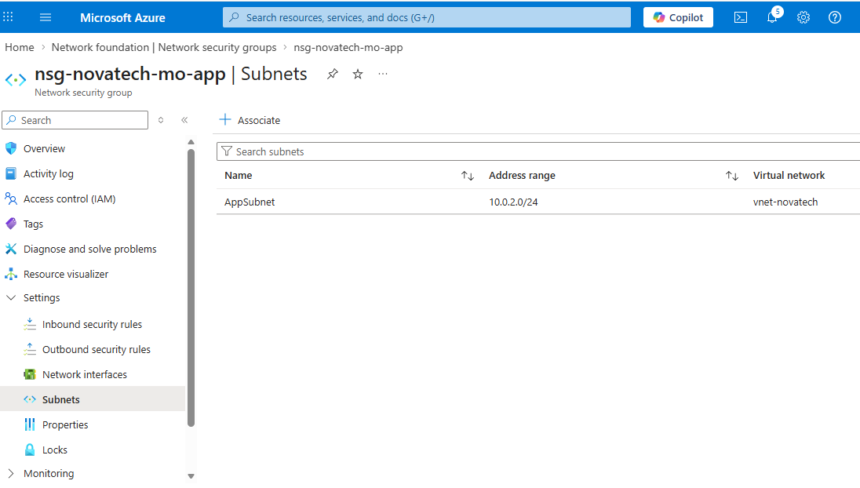
DataNSG has an explicit deny for Internet and allow from 10.0.2.0/24
In the DataNSG select Inbound security rules
Click on +Add
Under Source: select Service Tag
Source service tag: Select Internet
Select Deny and click OK
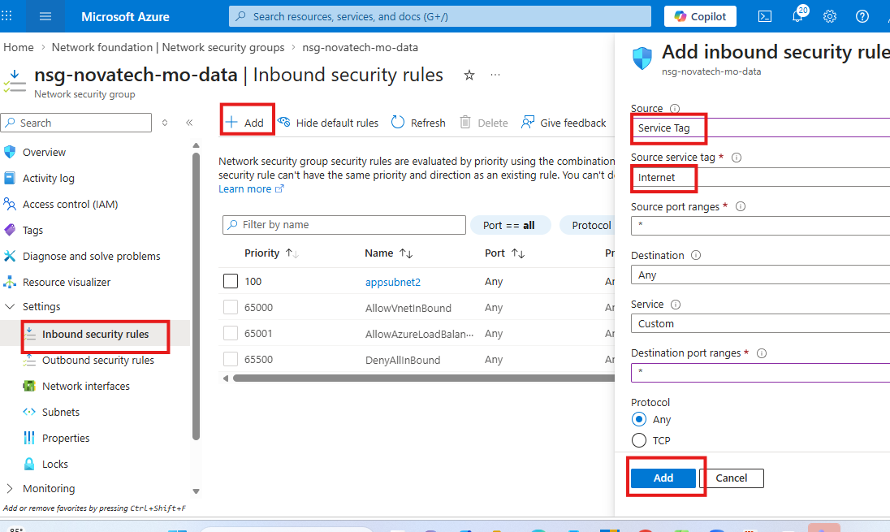

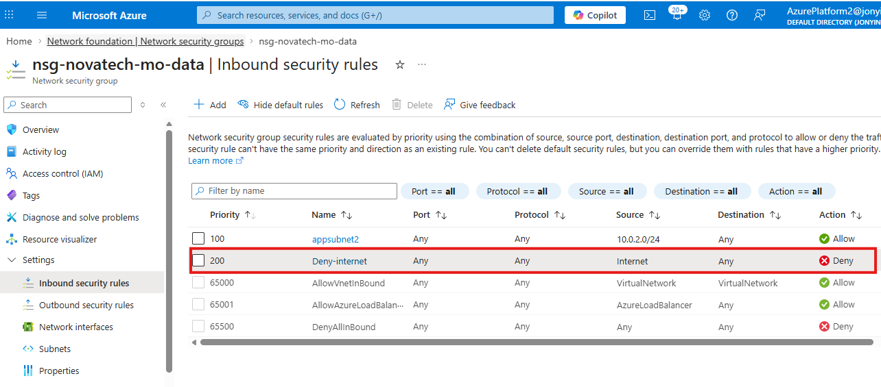

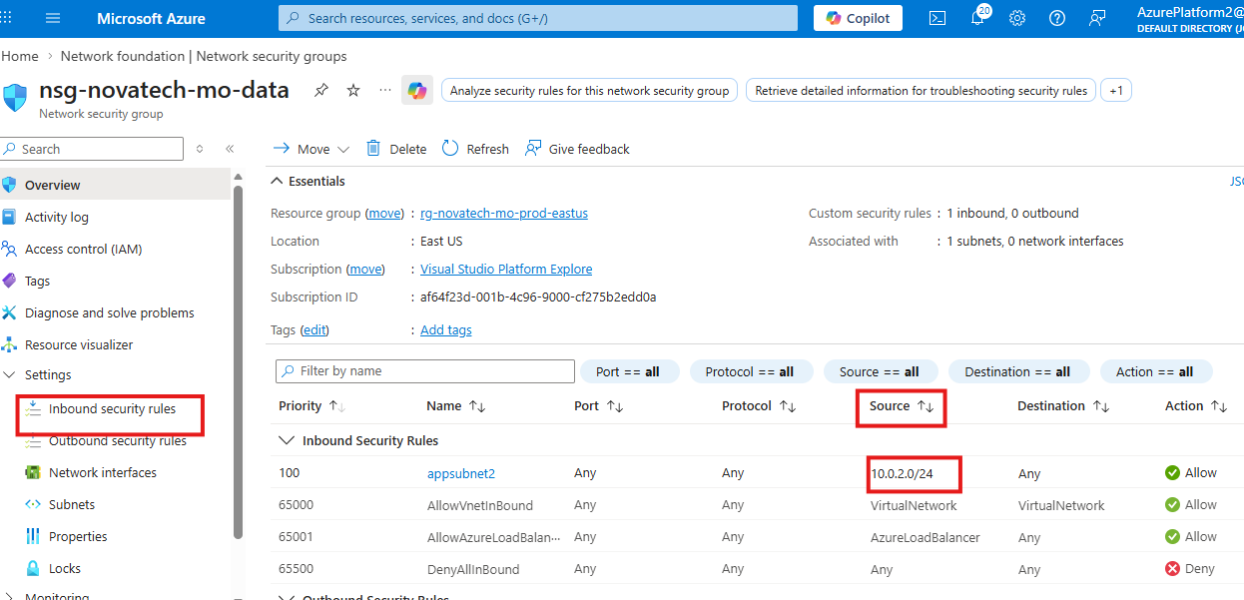

WebNSG allows 80 and 443 from Any source
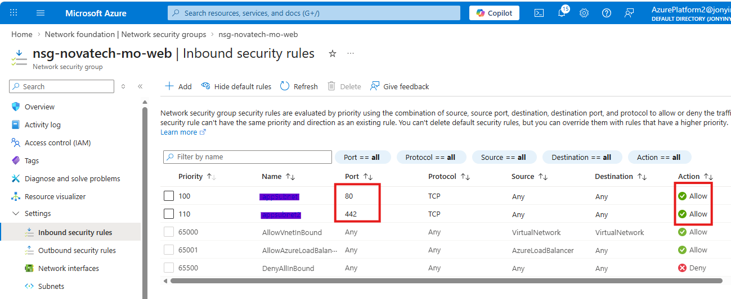

AppNSG allows 8080 only from 10.0.1.0/24
